Student name
Instructor
Course
Date

ELECTROPHILIC AROMATIC IODINATION EXPERIMENT LAB REPORT
Objectives
This experiment investigates aromatic iodination of vanillin in electrophilic substitution reaction using ethanol, bleach, and sodium iodine.
Introduction
The electrophilic substitution mechanism involves two reaction processes: addition and elimination reactions. Through the experiments, it’s evident that aromatic compounds can be formed from benzene aromatic rings. The benzene derivatives are arranged in ortho, para, or Meta, directing deactivating groups. Aromatic compounds undergo electrophilic substitution reactions, unlike alkenes which go through electrophilic addition. The best example of electrophilic aromatic substitution is the halogenation of aromatic complexes. Iodine is an appropriate reagent in halogenation reaction since it’s unreactive, and it is used together with oxidizing agents to allow the occurrence of iodination of the aromatic rings. In this experiment, vanillin undergoes a halogenation reaction to form iodovanillin by converting the iodine ion in sodium iodide to cation that bond in vanillin aromatic rings in ortho directing deactivating group.
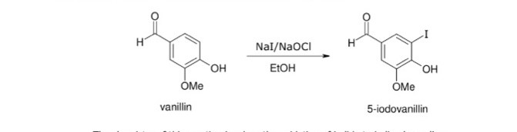
Scheme 1: electrophilic iodination of ortho vanillin

For this experiment, greener conditions may be applied in aromatic iodination of vanillin rather than using reagents such as sodium iodine and bleach in aqueous alcohol as the oxidizing agent.
Analysis of Green Chemistry Principle
During the experiment, all the 12 principles of green chemistry were observed effectively. All the reagents were used without wastage and cleaned all apparatus after the experiments. Safe chemicals were used to reduce toxicity and decompose all the waste carefully to avoid pollution. Chemicals used were well labeled to reduce impurities and minimize experiment time. The experiment was carried at room temperature for effective results.
Materials
- Ortho –vanillin
- Sodium hypochlorite
- Sodium iodide
- Hydrochloric acid
- Sodium thiosulfate
- 2-propanol
- Round-bottomed flask
- Erlenmeyer flask
- Filter papers
- Heat lamps
- Water bath
Procedure
Dissolve 1.0g of ortho-vanillin in 20ml of 90% ethanol in a 100-ml round–bottomed flask with a magnetic stir bar. 1.17g of sodium iodide was added to the solution then cooled to 0 degrees Celsius in ice –water bath. 12 ml of aqueous sodium hypochlorite solution dropwise to the stirred reaction mixture for 30minutes at 0 degrees Celsius. Sodium hypochlorite was added slowly to increase yield and easier purification. In addition, the color changed from pale yellow to red-brown or green. The solution is then stirred for 10 minutes, placed in a water bath, and allows the reaction to stir for 30minutes. The mixture is removed from the water bath while stirring continues. In the graduated cylinder, 10ml of sodium thiosulfate was measured and placed dropwise to the solution. HCL was added dropwise using a pipet. By use of pH, paper acidity is determined as HCL is added until pH is acidic. The solution is cooled for 10 minutes in ice bath water and filtration to obtain the product. The product was washed with 2ml of ice–cold water.
Transferred the product to a 125ml Erlenmeyer flask, and boiling stones were added.30ml of 2-propanol was placed in a 100ml beaker, and boiling stones were added, and the solvent was boiled. In the Erlenmeyer flask, 10ml of hot 2-propanol to the crude solid was added. Erlenmeyer flask was placed on the hot plate, and the mixture was heated. More 2-propanol was added to obtain a colored but clear solution. The flask was later transferred from hot plate to wire gauze, and it was covered with a small watch glass. The solution was cooled to room temperature, and the flask is placed in an ice bath for 5 minutes to ensure complete crystallization. The end product was collected through filtration methods. Then the product was dried between folds of filter paper, followed by a heat lamp.
Pre-lab questions for electrophilic of aromatic substitution
- Determine the yield and the melting point of the dry recrystallized product
The final weight of 5-Iodo-o-vanillin is 278.04g/mol, and the melting point is 127-130 degrees Celsius.
2. Run an IR spectrum of both ortho-vanillin and the products
IR spectrum reveals that the ortho-vanillin rings to be 1500cm, carbonyl around 1600-1700, aldehyde proton around 2700, and alcohol around 3000. Vanillin and newly formed compounds will form a new halogen that neighbors the aromatic proton. IR spectrum shows the differences that display the impurity of the product

Results
Ortho-vanillin grams =1.0015g
Moles =mass/molar mass
1.0015/152= 0.007g/moll
Sodium iodine grams=1.1915g
Moles of sodium iodine=1.1915/150=0.008
Product theoretical yield =0.018
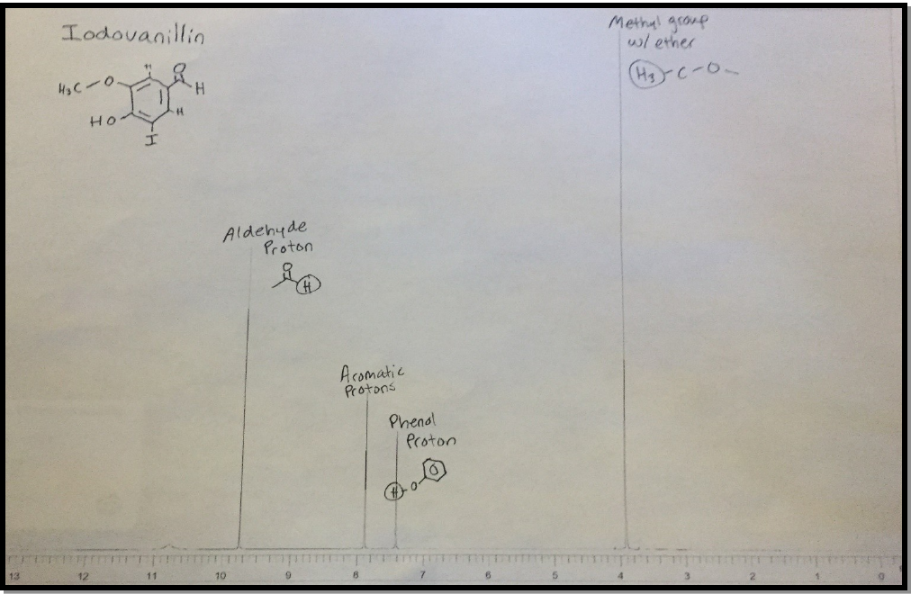The analyzed proton of the end product
Discussion
From the IR spectrum carried out, it was evident that there were various impurities in the compound. Therefore the IR cannot be precisely analyzed due to the errors of impurities. The process did not melt at required temperatures due to the high addition of acid during heating which completed the reaction before all the reactants react to form the product. However, the method is more effective during synthesizing iodinated aromatic compounds when all the procedures are followed appropriately.

Post –lab questions
- Identify the electrophile and the nucleophile in the reaction
Electrophile –vanillin aromatic ring
Nucleophile-Iodine
- How is the electrophile generated? Write an equation to support your answer.
Electrophilic is generated from a compound that attracts pair of electrons.

- Product theoretical yield
Ortho-vanillin grams =1.0015g
Moles =mass/molar mass
1.0015/152= 0.007g/mol
Product theoretical yield =0.018
- Product percentage yield
0.007/0.018x100=3.9%
- Write equation of reaction
2NaI+NaoCl +H20 NaCl +I2+2NaoH

- Expected melting points for reactants and products.
Melting points 260 degrees Celsius

References
Kirchhoff, M., & Ryan, M. A. (2002). Greener Approaches to Undergraduate Chemistry Experiments. American Chemical Society, 1155 16th Street NW, Washington, DC 20036.

